QUESTION NO . 01
a) 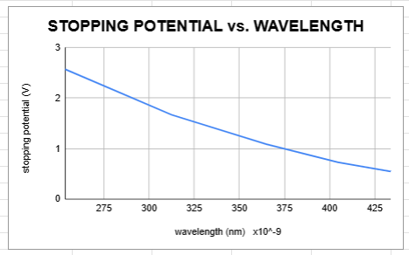
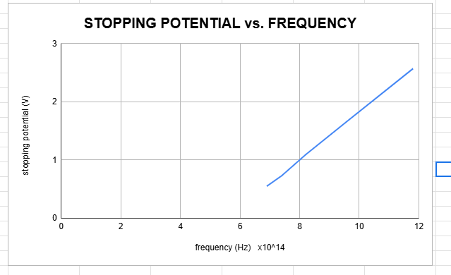
b) Plank’s constant (h) :
m=y2-y2/x2-x1 m=1.8-1/(*10^14) 10-8 m=4*10^-15
h=me
h=(4*10^-15)*(1.6*10^-19)
h=6.4*10^-34 Js
c) Work function (Φ) for lithium :
Φ=hfo
Φ=(6.4*10^-34)*(4.9*10^14)
Φ=3.136*10^-19 eV
Percentage error =|estimated-actual/actual|* 100%
=|(6.4*10^-34)-(6.63*10^-34)/(6.63*10^-34)|*100%
=|-0.3| =0.3%
QUESTION NO . 02
Given Data for both parts :
ΦNa (sodium’s work function) = 2.64 eV
ΦAg (silver’s work function) = 4.73 eV

a)
Solution:
The energy of incident light E is assumed to be constant for both the metals. The K.E of emitted electrons is given by:
K.E= hf-Φ
K.E= E-Φ
As, K.E= ½ mV^2
Then, V= √2K.E/m

The ratios of K.E can be given as:
K.E of Na= E- ΦNa
K.E of Ag= E-ΦAg

To eliminate E,
Since ΦNa < ΦAg then, K.E of Na > K.E of Ag.
ΔV= V Na- V Ag
ΔV= √2/m (√E- ΦNa -√ E-ΦAg) ( After cancelling E )
ΔV= √2/m (ΦNa -ΦAg)

Substitute the values:
ΔV= √2/9.1*10^-31 *(√ 4.73-2.64)
ΔV= 8.57x10^5 m/s

- This proves that the electrons emitted from Sodium are 8.57x10^5 m/s faster than that of Silver, the reason being the work function (Φ) of Sodium (Na) is lower than that of Silver (Ag).

b)
Solution:
Cut off wavelength is given by:
λNa = hc / Φ (1)
λAg = hc / Φ (2)

from eq.(1)
λNa = hc / Φ
λNa = (6.625x10-34)x(3x108)/(4.23x10-19)
λNa= 4.7x10-7m or 470 nm

from eq.(2)
λAg = hc / Φ
λAg = (6.625x10-34)x(3x108)/(7.58x10-19)
λAg= 2.62x10-7m or 262 nm

- cutoff wavelength of sodium (Na) : 470nm
- cutoff wavelength of silver (Ag) :262nm

Natasha saeed

